Virtual Buildings and Grounds Sub-Committee Report
Wednesday, May 12, 2021
Broadcast from the Media Arts Studio
454 Broadway, Cambridge, MA

Called for the purposes to discuss the health & safety working group recommended changes/updates to the safety manual, the planned temporary move of the Tobin School and discuss the request from the Cambridge Election Commission

Ms. Warren echoed concern about the policy change

Mr. Zou asked about screening children

Dr. Ericson talked about how the study

Ms. Valenzuela asked about transparency.

Mr. Maloney talked about the safety manual is a guidance.

Mr. Maloeny provided background on the information

Member Weinstein
Dan Monahan talked about how we dn

MS. Cranton talked about not reverting the change back, she just asked about bringing out the changes more slowly.

Barrett Reinhorn reiterated the parents.

Alisa Khan

Time for him and Fred to have a quick conversation

Members Present: Member Rojas, Member Fantini, Vice Chair Bowman

Others Present: James Maloney, Chief Operating Officer

Attest:
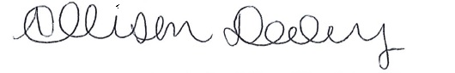
Allison Daley
Confidential Secretary to the Office of the School Committee

