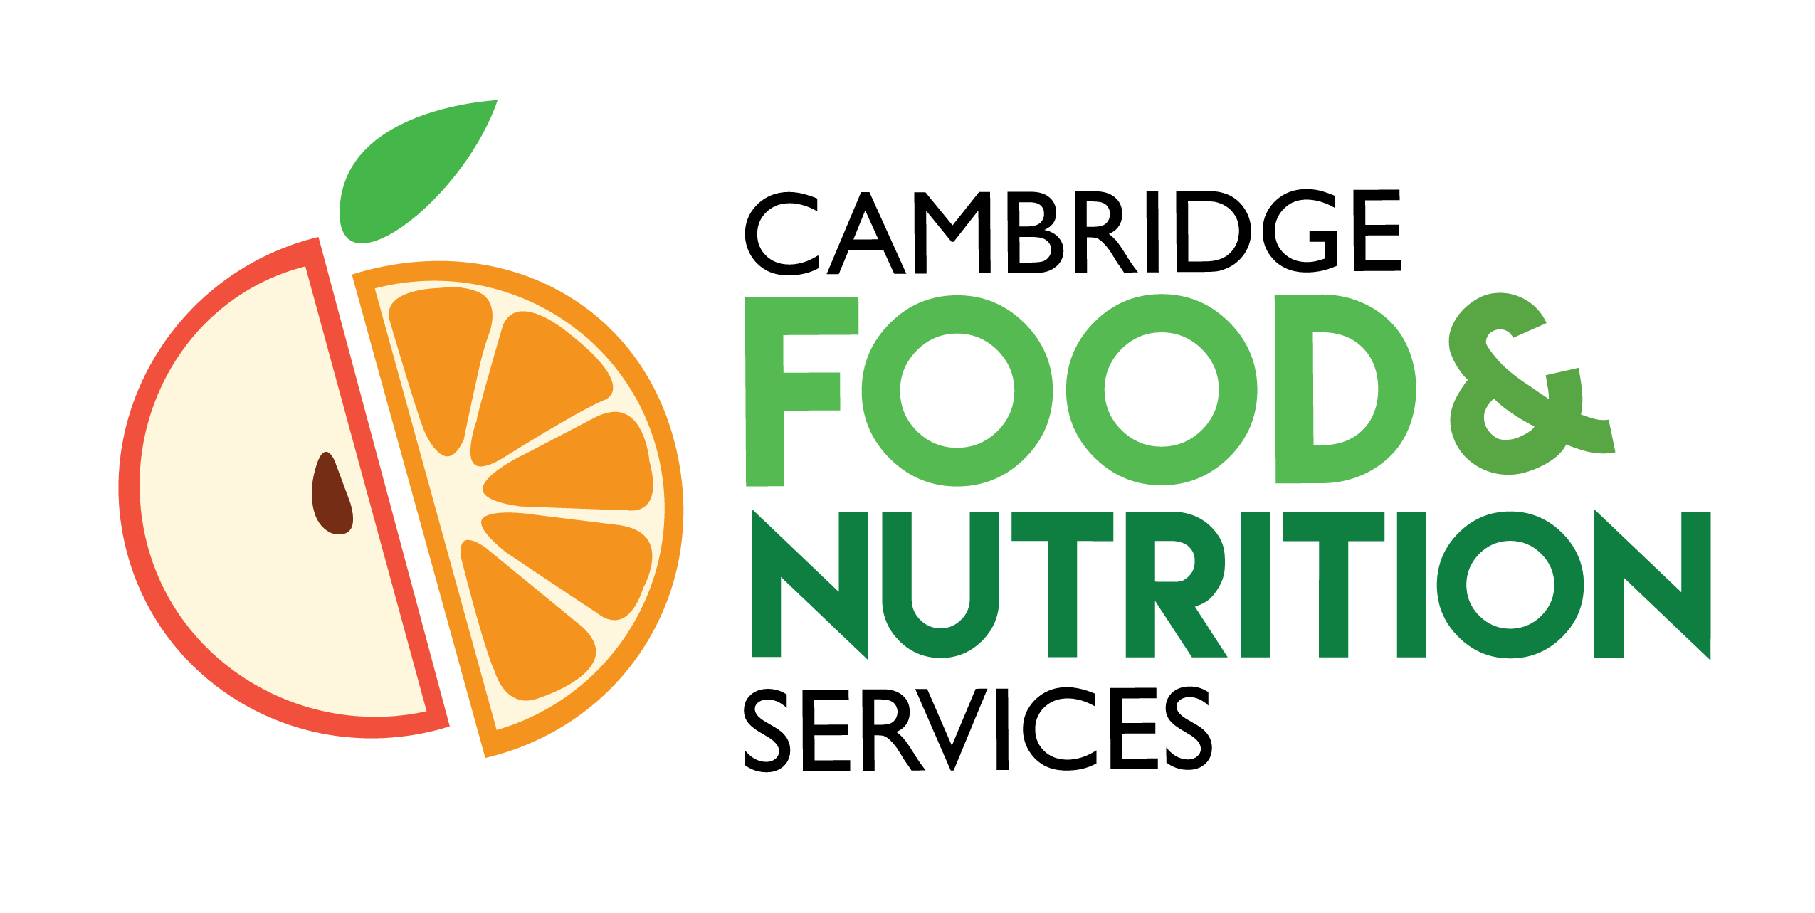
CPS Food and Nutrition Service
Field Trip Lunch Order Form

Please submit this form to your kitchen manager at least 10 school days* before your scheduled field trip. This sheet will act as a guide for kitchen staff on what needs to be prepared for your outing. If you do not need any meals, you are still required to notify Food and Nutrition via this form on how many students will be absent or gone from school that day.
Meals will be ready for pick up at the time you designate below, along with a student roster sheets for easy meal claiming. All roster sheets must note which students received a meal and should be turned into the kitchen immediately the following school day.
If you have any questions, please do not hesitate to contact your school kitchen, or the Food and Nutrition Office at 617-349-6858.
Required Field Trip / Event Information

Point of Contact Name:
Class/Room Number(s) (if applicable):
Phone Number:
Estimated # of Students Attending Trip:
Date of Field Trip:
MON TUES WED THUR FRI
Meal Pick Up Time:
(N/A if no meals needed)

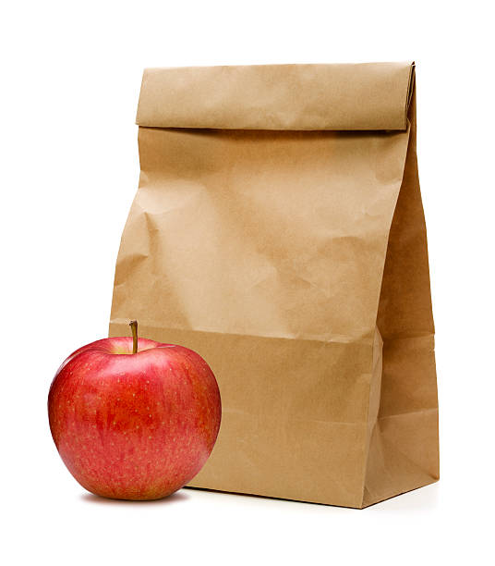
Field Trip Meal Total Meals Tally
Estimated # of Meals Ham and Cheese Sandwich Meal
Comes with Fresh Fruit, Snack Crackers, and Milk or Juice

Estimated # of Meals Peanut Butter and Jelly Sandwich Meal
Comes with Fresh Fruit, Snack Crackers, and Milk or Juice

Estimated # of Meals Nut Free-Sun Butter and Jelly Sandwich Meal
Comes with Fresh Fruit, Snack Crackers, and Milk or Juice

Field Trip Food Safety
Here are some bagged lunch storage tips to help you avoid food borne illness while on your trip.
- Pack the bagged lunches in insulated coolers with ice packs (both may be available through Food Services)
- Ask the field trip site you’re visiting if they have refrigeration space to store bagged lunches once you arrive.
- If refrigeration space is not available, store the coolers containing the bagged lunches in a secure area out of the sun.
- Have students thoroughly wash/sanitize their hands before eating.

